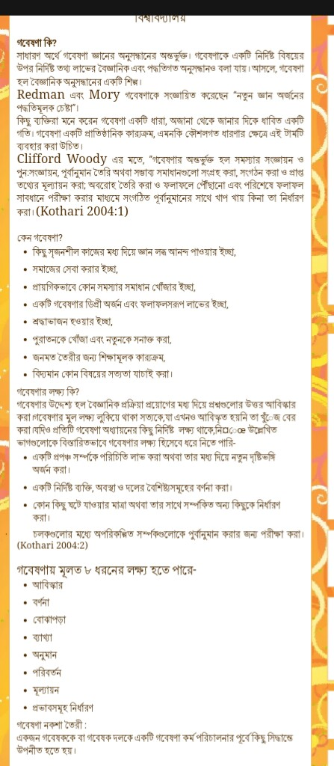

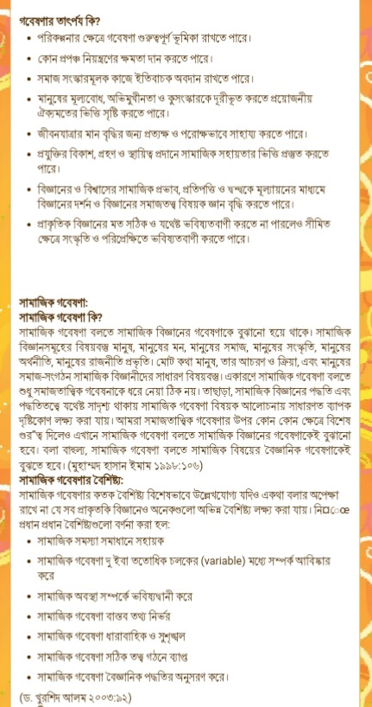
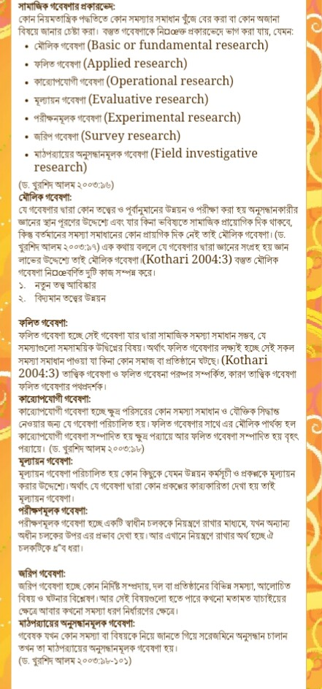
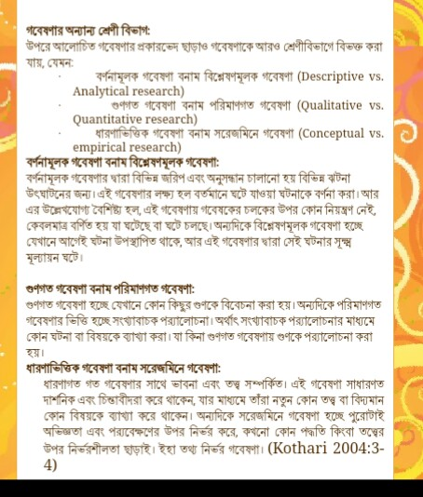
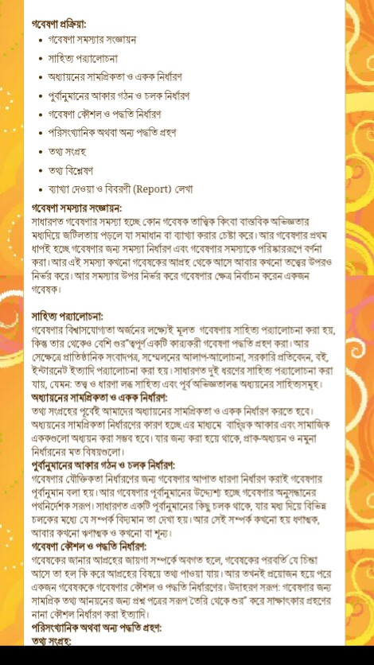
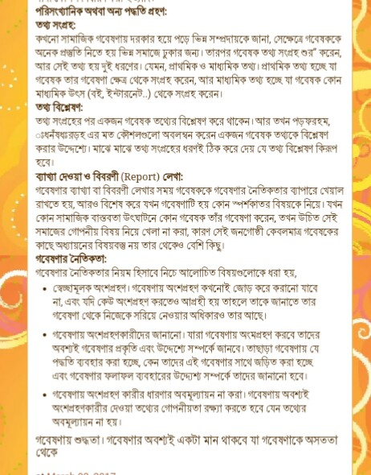
………………………………………………………………………………………………………………………………………
NOTES PREPARED BY SUVAJIT PAUL.
GOVT. APPROVED COLLEGE TEACHER(SACT:1)
DEPT. OF GEOGRAPHY. RANAGHAT COLLEGE.

